**UNIT-IV**

# CATHODE RAY OSCILLOSCOPE

**Motion of electron in magnetic and electric fields**

The force (F) on wire of length L carrying a current I in a magnetic field of strength B is given by the equation:

F = BIL

But Q = It and since Q = e for an electron and v = L/t you can show that :

Magnetic force on an electron = BIL = B[e/t][vt] = Bev where v is the electron velocity

In a magnetic field the force is always at right angles to the motion of the electron (Fleming's left hand rule) and so the resulting path of the electron is circular (Figure 1).

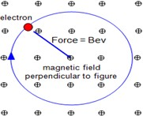

Fig 1.1 Force of an electron in magnetic field

Therefore :

Magnetic force = Bev = centripetal force

Charged particles move in circles at a constant speed if projected into a magnetic field at right angles to the field.Charged particles move in straight lines at a constant speed if projected into a magnetic field along the direction of the field.

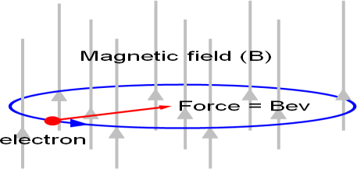

Fig 1.2 Motion of an electron in magnetic field

If the electron enters the field at an angle to the field direction the resulting path of the electron (or indeed any charged particle) will be helical as shown in figure 3

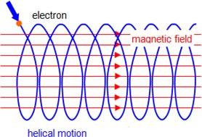

Fig 1.3 Helical path of an electron in magnetic field Path of the electron in an electric field:

We will consider next the case of an electron entering a uniform electroc field between two parallel plates (Figure 4). The potential difference between the plates is V and the plates are aligned along the x direction and the electron enters the field at right angles to the field lines:

The force on the electron is given by the equation: F = eE = eV/d

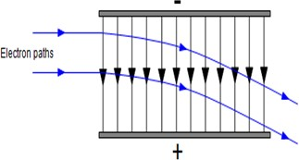

Fig 1.4 force on the electron in electric field

# Cathode Ray Oscilloscope

The cathode Ray Oscilloscope or mostly called as CRO is an electronic device used for giving the visual indication of a signal waveform.It is an extremely useful and the most versatile instrument in the electronic industry. CRO is widely used for trouble shooting radio and television receivers as well as for laboratory research and design.Using a CRO, the wave shapes of alternating currents and voltages can be studied. It can also be used for measuring voltage, current, power, frequency and phase shift.

# Block Diagram of CRO (Cathode Ray Oscilloscope)

The figure below shows the block diagram of a general purpose CRO .

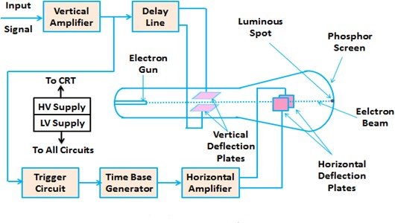

Fig 4.1 Block Diagram of CRO

As we can see from the above figure above, a CRO employs a cathode ray tube (CRT) ,which acts as the heart of the oscilloscope. In an oscilloscope, the CRT generates the electron beam which are accelerated to a high velocity and brought to focus on a fluorescent screen. This screen produces a visible spot where the electron beam strikes it. By deflecting the beam over the screen in response to the electrical signal, the electrons can be made to act as an electrical pencil of light which produces a spot of light wherever it strikes.

For accomplishing these tasks various electrical signals and voltages are needed, which are provided by the power supply circuit of the oscilloscope. Low voltage supply is required for the heater of the electron gun to generate the electron beam and high voltage is required for the cathode ray tube to accelerate the beam. Normal voltage supply is required for other control units of the oscilloscope.

Horizontal and vertical deflection plates are fitted between the electron gun and the screen so that these can deflect the beam according to the input signal. To deflect the electron beam on the screen in horizontal direction i.e. X-axis with constant time dependent rate, a time base generator is provided in the oscilloscope. The signal to be viewed is supplied to the vertical deflection plate through the vertical amplifier, so that it can amplify the signal to a level that will provide usable deflection of the electron beam. As the electron beam is deflected in X-axis as well as Y-axis, a triggering circuit is provided for synchronizing these two types of deflections so that horizontal deflection starts at the same point of the input vertical signal each time it sweeps. Since CRT is the heart of the oscilloscope, we are going to discuss its various components in detail.

# Cathode Ray Tube

The cathode ray tube or CRT is a vacuum tube of special geometrical shape which converts an electrical signal into a visual one.A CRT makes available a large number of electrons which are accelerated to high velocity and are brought to focus on a fluorescent screen where it produces a spot when strikes it. The electron beam is deflected during its journey in response to the applied electrical signal. As a result, the electrical signal waveform is displayed visually.

The figure below shows various parts of a cathode ray tube (CRT) .

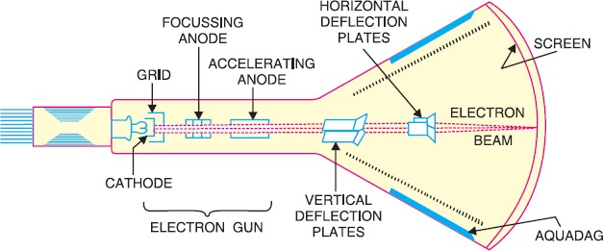

Fig 1.6 Cathode Ray Tube

Now we will discuss each part of the CRT in detail.

**Glass Envelope**

It is a conical highly evacuated glass housing which maintains vacuum inside it and supports various electrodes.The inner wall of CRT between the neck and screen are usually coated with a conducting material known as aquadag. This coating is electrically connected to the accelerating anode so that the electrons which accidentally strike the walls are returned to the anode. This prevents the walls from charging to a high negative potential.

## Electron Gun Assembly

The electron gun assembly consists of an indirectly heated cathode, a control grid, a focussing anode and an accelerating anode and it is used to produce a focused beam of electrons.The control grid is held at negative potential w.r.t. cathode. However, the two anodes are held at high positive potential w.r.t. cathode. The cathode consists of a nickel cylinder coated with oxide coating and provides a large number of electrons. The control grid encloses the cathode and consists of a metal cylinder with a tiny circular opening to keep the electron beam small. By controlling the positive potential on it, the focusing anode focuses the electron beam into a sharp pin point

.Due to the positive potential of about 10,000 V on the accelerating anode which is much larger than on the focusing diode, the electron beam is accelerated to a high velocity. In this way, the electron gun assembly forms a narrow, accelerated electron beam which produces a spot of light when it strikes the screen.

# Deflection Plate Assembly

It consists of two sets of deflecting plates within the tube beyond the accelerating anode and is used for the deflection of the beam.

One set is called as vertical deflection plates and the other set is called horizontal deflection plates.

The vertical deflection plates are mounted horizontally in the tube. On application of proper potential to these plates, the electron beam can be made to move up and down vertically on the screen.

The horizontal deflection plates are mounted vertically in the tube. On application of proper potential to these plates, the electron beam can be made to move right and left horizontally on the screen.

# Screen

The screen is coated with some fluorescent materials such as zinc orthosilicate, zinc oxide etc and is the inside face of the tube.

When high velocity electron beam strikes the screen, a spot of light appears at the point of impact. The colour of the spot depends upon the nature of fluorescent material.

**Working of Cathode Ray Tube**

As the cathode is heated, it produces a large number of electrons. These electrons pass through the control grid on their way to the screen. The control grid controls the amount of current flow as in standard vacuum tubes. If negative potential on the control grid is high, fewer electrons will pass through it. Hence the electron

beam will produce a dim spot of light on striking the screen. Reverse will happen when the negative potential on the control grid is reduced.Therefore, the intensity of the light spot on the screen can be controlled by changing the negative potential on the control grid.After leaving the control grid, the electron beam comes under the influence of focusing and accelerating anodes.Since, the two anodes are at high positive potential, therefore, they produce a field which acts as electrostatic lens to converge the electron beam at a point on the screen.After leaving the accelerating anode, the electron beam comes under the influence of vertical and horizontal deflection plates.When no voltage is applied to these deflection plates, the electron beam produces a spot of light at the centre as shown by point O in fig below on the screen.

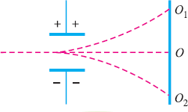

Fig 1.7 Movement of electron beam under deflection plates

If the voltage is applied to the vertical deflection plates only, the electron beam and so as the spot of light will be deflected upwards i.e. point O1. Ans if the potential on the plates is reversed, the spot of light will be deflected downwards i.e. point O2.

Similarly, the spot of light can be deflected horizontally by applying voltage across the horizontal deflection plates.

# Electrostatic Deflection

In order to find out the expression for the deflection, let us consider a system as shown below:

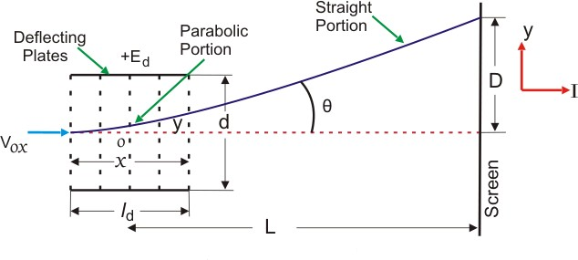

Fig 1.8 Electrostatic deflection

Fig 1.9 Refraction of an electron beam

In the above system we have two plates A and B which are at potential +E and 0 respectively. These plates are also called deflection plates. The field produced by these plates is in the direction of positive y axis and there is no force along the x-axis. After deflection plates we have screen through which we can measure net deflection of the electron beam. Now let us consider a beam of electron coming along the x-axis as shown in the figure. The beam deflects by angle A, due presence of electric field and deflection is in the positive direction of y axis as shown in the figure. Now let us derive an expression for deflection of this beam. By the conservation of energy, we have loss in potential energy when the electron moves from cathode to accelerating anode should be equal to gain in kinetic energy of electron.

Mathematically we can write,

http://www.electrical4u.com/equations/cro-01-21-05-14.gif

Where, e is the charge on electron, E is the potential difference between the two plates, m is the mass of electron, and v is the velocity of the electron. Thus, eE is loss in potential energy and 1/2mv1/2 is the gain in kinetic energy. From equation (1) we have velocity v=(2eE/m)1/2. Now we have electric field intensity along the y axis is E/d, therefore force acting along the y axis is given by F = eE /d where d is the separation between the two deflection plates. Due to this force the electron will deflect along the y axis and let the deflection along y axis be equal to D which is marked on the screen as shown in the figure. Due to the force F there is net upward acceleration of the electron along positive y axis and this acceleration is given by Ee/(d × m).Since the initial velocity along positive y direction is zero therefore by equation of motion we can write the expression of displacement along y axis as,

http://www.electrical4u.com/equations/cro-02-21-05-14.gif

http://www.electrical4u.com/equations/cro-03-21-05-14.gifAs the velocity along the x direction is constant therefore we can write displacement as,

http://www.electrical4u.com/equations/cro-04-21-05-14.gifWhere, u is velocity of electron along x axis. From equations 2 and 3 we have,

http://www.electrical4u.com/equations/cro-05-21-05-14.gifWhich is the equation of trajectory of the electron. Now on differentiating the equation 4 we have slope i.e.

Where, l is the length of the plate. Deflection on the screen can be calculated as,

http://www.electrical4u.com/equations/cro-06-21-05-14.gif

Distance L is shown in the above figure .Final expression of D can be written as,

http://www.electrical4u.com/equations/cro-07-21-05-14.gif

From the expression of deflection, we calculate deflection sensitivity as,

http://www.electrical4u.com/equations/cro-08-21-05-14.gif

# Vertical Deflection System:

The function of vertical deflection system is to provide an amplified signal of the proper level to drive the vertical deflection plates without introducing any appreciable distortion into the system.

The input sensitivity of Many CROs is of the order of a few milli-volts per division and the voltage required for deflecting the electron beam varies from approximately 100 V (peak to peak) to 500 V depending on the accelerating voltage and the construction of the i tube. Thus the vertical amplifier is required to provide this desired gain from milli-volt input to several hundred volt (peak to peak) output. Also the vertical amplifier should not distort the input waveform and should have good response for entire band of frequencies to be measured.The deflection plates of CRO act as plates of a capacitor and when the input signal frequency exceeds over 1 MHz, the current required for charging and discharging of the capacitor formed by the deflection plates increases. So the vertical amplifier should be capable of supplying current enough to charge and discharge the deflection plate capacitor.

As we know that electrical signal is delayed by a certain amount of time when transmitted through an electronic circuitry. In CRO, output signal voltage of the vertical amplifier is fed to the vertical plates of CRT and some of its portion is used for triggering the time base generator circuit, whose output is supplied to the horizontal deflection plates through horizontal amplifier. The whole process, which includes generating and shaping of a trigger pulse and starting of a time-base generator and then its amplification, takes time of the order of 100 ns or so. So the input signal of the vertical deflection plates of a CRT is to be delayed by at least the same or little more amount of time to allow the operator to see the leading edge of the signal waveform under study on the screen. For this purpose, delay line circuit is introduced between vertical amplifier and the plates of CRT, as shown in figure.

# Horizontal Deflection System:

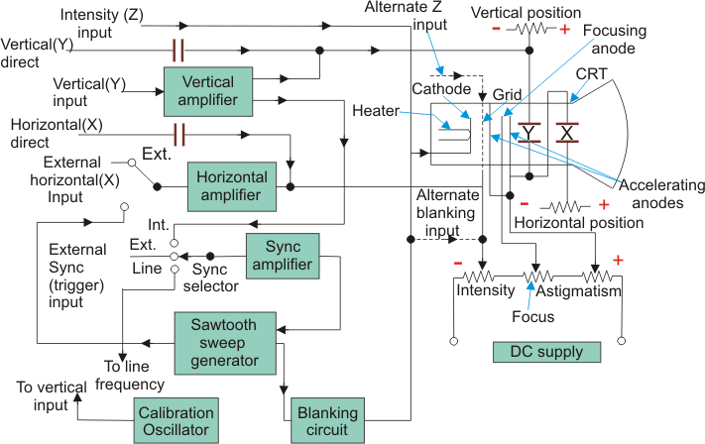

Fig 1.10 Simplified Block Diagram of a General Purpose Oscilloscope

External signal is applied to horizontal deflection plates through the horizontal amplifier at the sweep selector switch in EXT position, as shown in figure. The horizontal amplifier, similar to the vertical amplifier, increases the amplitude of the input signal to the level required by the horizontal deflection plates of CRT. When the function of time is required to be displayed on the screen of CRT, INT position of sweep selector switch is used. Before going further we should make ourselves clear first about the linear time base pattern. Assume that we supply an ideal saw-tooth signal voltage to the horizontal deflection plates, keeping vertical deflection plates at zero potential, as shown in figure.

At the starting point A in time, signal voltage is maximum but negative so the spot on the screen of CRO is at the extreme left position. Further at point B in time, signal voltage applied to the horizontal plates is zero so the spot is in the centre position on the screen. Now when voltage increases in + ve direction and becomes maximum just before the point C, the spot on the screen is at the extreme right side of the screen. Just after the point C, next cycle of saw-tooth voltage signal starts and again voltage becomes maximum negative so the spot goes back to the extreme left position of the screen from right position in no time.

From the above discussions we may conclude that

(i) The spot moves from left to right over the same path again for every cycle of sawtooth voltage applied to the horizontal deflection plates, so a horizontal line appears on the screen of CRO. (it) The spot moves from left to right on the screen with the uniform speed. Thus it produces a linear time base to display function of time on the screen of CRO.

For making idea of time base more clear let us discuss an application. Suppose a sine-wave voltage signal y of time period T is applied to the vertical deflection plates and a saw-tooth voltage signal vhof time period T is applied to horizontal deflection plates, as shown in figure. At zero time, the spot is at extreme left vertically central position on the screen. Because of zero value of VV and maximum negative values of Vh. At time T/4, the spot is at one-fourth way on the screen in horizontal direction and at maximum positive deflection above the centre line in vertical direction because of maximum positive value of VV. At time T/2, values of both VV and Vh are zero, so the spot is at the central position of the screen. At time 3T/4, the spot is the three-fourth way on the screen in horizontal direction and at the maximum negative deflection in vertical direction. Finally, at the end of time T, the spot is at extreme right vertically central position of the screen and then it moves back to begin a new trace. In this way, sine-wave voltage applied to the vertical deflection system appears on the screen. If the period of sine-wave is reduced to half then two sine-wave cycle appears on the screen.

From the above discussion, it is obvious that the following conditions are to be satisfied in order to have a waveform of the input signal applied to vertical deflection system as a stationary pattern on the screen of CRO.

1. Both horizontal and vertical signals must start at the same instant.
2. Ratio of frequency of horizontal and vertical signals should be a rational or fractional number.

For satisfying the above conditions, sawtooth-wave is generated and synchronised with the vertical input signal by the trigger circuit and time base generator, as shown in figure and explained above.

In the INT position of sweep selector switch, horizontal amplifier receives an input from the time base generator,which provides a time base, and controls the rate at which the beam is scanned across the face of the CRT. Time base generator is triggered or initiated by a trigger circuit which ensures that the horizontal sweep starts at the same point of the vertical input signal. As explained earlier, it is necessary to synchronize the sweep with the signal under measurement in order to obtain stationary pattern. Ratio of frequency of the time base and of the signal under measurement should be a rational number, otherwise pattern on the screen will not be stationary. A synchronous selector switch is used, as shown in figure, to select the type of synchronization. In the internal mode of switch the trigger is obtained from the vertical amplifier, input of which is signal under measurement.

In the external position of switch, the trigger is obtained from the external source. In the third position of switch i.e. line, trigger is obtained from the power supply i.e. 230 V and 50 Hz.

Two types of sweep generators are usually used. In the first one sawtooth signal of constant frequency is generated whether there is any input signal for vertical signal or not. That is why it is called free running type. In this it is essential to adjust the frequency of the sawtooth to get stationary pattern. In the second type of sweep generator, sweep is triggered by the signal under measurement so there is no need for any adjustment for synchronization.

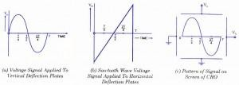

Fig 1.11 *Signal output on CRO*

Sometimes, non-sawtooth sweep is also used in CRO for some special applications.

Like the vertical system horizontal system also consists of horizontal amplifiers to amplify the weak input voltage signals but in contrast to vertical deflection system, horizontal deflection plates are fed by a sweep voltage that provides a time base as shown above. As shown in the circuit diagram, the saw tooth sweep generator is triggered by the synchronizing amplifier when the sweep selector switch is in the internal position and thus the triggered saw tooth generator gives input to the horizontal amplifier by following this mechanism. Now there are four types of sweeps:

* 1. **Free Running or Recurrent Sweep** As the name suggests, the saw tooth waveform is repetitive i.e. a new sweep is started immediately after the previous sweep.
  2. **Triggered Sweep** Some time the waveform to be observed may not be periodic so it is desired that the sweep circuit remain inoperative and the sweep be initiated by the waveform under examination. In such cases we use triggered sweep.
  3. **Driven Sweep** Generally a driven sweep is used where the sweep is free running but triggered by the signal under test.
  4. **Non Saw Tooth Sweep** This is used for finding the phase difference between the two voltages. Another important application is that we can compare frequency of input voltages using non saw tooth sweep.

# Dual Beam Oscilloscope:

The dual-beam oscilloscope emits two electron beams that are displayed simultaneously on a single scope, which could be individually or jointly controlled. The construction and working of the dual beam oscilloscope are completely different from dual trace oscilloscope. The tubes are more complicated to build, and the whole thing is more expensive.A special type of **double beam oscilloscope** can display two electrons beam by generating or deflecting beams. Now a days, **double beam oscilloscope** is outdated, as this function could be performed by the digital scope with greater efficiency and they do not require a dual-beam display. The digital scope captures a single beam of electron and simultaneously and splits into many channels.

# Construction of Dual Beam Oscilloscope:

There is two individual vertical input channel for two electron beams coming from different sources. Each channel has its own attenuator and pre-amplifier. Therefore, the amplitude of each channel can be controlled eventually.

The two channels may have common or independent time base circuits which allow different sweep rates. Each beam passes through different channels for separate vertical deflection before it crosses a single set of horizontal plate. The horizontal amplifier is compiled by sweep generator to drive the plate which gives common horizontal deflection. The horizontal plates allow both the electron beams across the screen at the same time.

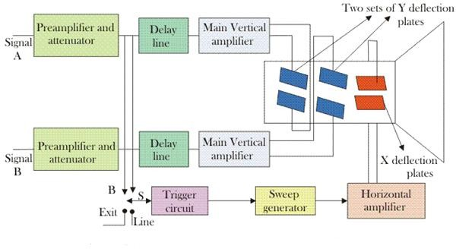

Fig 1.12 Dual beam oscilloscope with time base

Dual beam oscilloscope can generate the two electron beams within the cathode ray tube either by using double electron gun tube or by splitting beam. In this method, the brightness and focus each beam are controlled separately. But two tubes increases the size and weight of the oscilloscope and it looks bulky.

The other method is split beam tube, a single electron gun is used in this method. There is a horizontal splitter plate between the Y deflection plate and last anode. The potential of the plate is same as that of the last anode and it goes along the length of the tube between the two vertical deflection plates. Therefore, it isolates the two channels. As the single beam is split into two, its brightness of the resultant beam is half of the original. At high-frequency operation, it works as a disadvantage. The alternative way to improve the brightness of resultant beam is to have two sources in the last anode instead of one so that beams emerge from it.

# Dual Trace Oscilloscope:

Fig. 7 illustrates the construction of a typical dual trace oscilloscope. There are two separate vertical input channels, A and B, and these use separate attenuator and preamplifier stages. Therefore the amplitude of each input, as viewed on the oscilloscope, can be individually controlled.

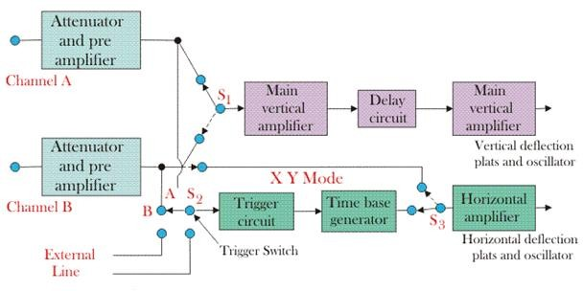

Fig 1.13 Block diagram of dual trace oscilloscope

After pre-amplification the two channels meet at an electronic switch. This has the ability to pass one channel at a time into the vertical amplifier, via the delay line. There are two common operating modes for the electronic switch, called alternate and chop, and these are selected from the instrument's front panel.

### Alternate mode:

The alternate mode is illustrated in Fig.8. In this the electronic switch alternates between channels A and B, letting each through for one cycle of the horizontal sweep. The display is blanked during the flyback and hold-off periods, as in a conventional oscilloscope. Provided the sweep speed is much greater than the decay time of the CRT phosphor, the screen will show a stable display of both the waveform at channels A and B. The alternate mode cannot be used for displaying very low frequency signals.

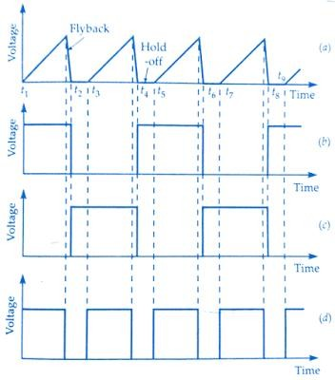

Fig.1.14 Waveforms for a dual channel oscilloscope operating in alternate mode;

(a) Horizontal sweep voltage(b)Voltage to channel A(c) Voltage to channel B(d)Grid control voltage

### Chopped Operating mode

In this mode the electronic switch free runs at a high frequency of the order of 100 kHz to 500 kHz. The result is that small segments from channels A and B are connected alternately to the vertical amplifier, and displayed on the screen. Provided the chopping rate is much faster than the horizontal sweep rate, the display will show a continuous line for each channel. If the sweep rate approaches the chopping rate then the individual segments will be visible, and the alternate mode should now be used.

The time base circuit shown in Fig. 7 is similar to that of a single input oscilloscope. Switch S2 allows the circuit to be triggered on either the A or B channel waveforms, or on line frequency, or on an external signal. The horizontal amplifier can be fed from the sweep generator or the B channel via switch S1. This is the X - Y mode and the oscilloscope operates from channel A as the vertical signal and channel B as the horizontal signal, giving very accurate X - Y measurements.

Several operating modes can be selected from the front panel for display, such as channel A only, channel B only, channels A and B as two traces, and signals A + B, A - B, B - A or - (A

+ B) as a single trace.

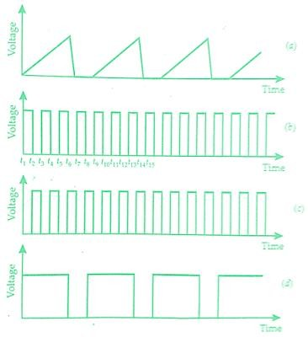

Fig1.15Waveforms for a dual channel oscilloscope operating in chopped mode;

(a) horizontal sweep voltage(b)voltage to channel A(c) voltage to channel B(d)Grid control voltage

# Sampling Oscilloscope:

An ordinary oscilloscope has a B.W. of 10 MHz the HF performance can be improved by means of sampling the input waveform and reconstructing its shape from the sample, i.e. the signal to be observed is sampled and after a few cycles sampling point is advanced and another sample is taken. The shape of the wave form is reconstructed by joining the sample levels together. The sampling frequency may be as low as 1/10th of the input signal frequency .As many as 1000 samples are used to reconstruct the original waveform.

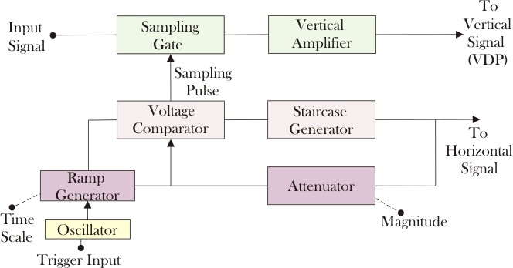

### Fig 1.16 Sampling oscilloscope

The input is applied to the sampling gate. The input waveform is sampled whenever a sampling pulse opens the sampling gate. The sampling must

be synchronized with the input signal frequency. The signal is delayed in the vertical amplifier, allowing the horizontal sweep to be initiated by the input signal. The waveforms are shown in fig.At the beginning of each sampling cycle, the trigger pulse activates an oscillator and a linear ramp voltage is generated. This ramp voltage is applied to a voltage comparator which compares the ramp voltage to a staircase generate-When the two voltages are equal in amplitude, the staircase advances one step and a sampling pulse is generated, which opens the sampling gate for a sample of input voltage.The resolution of the final image depends upon the size of the steps of the staircase generator. The smaller the size of the steps the larger the number of samples and higher the resolution of the image**.**

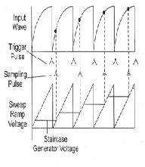

Fig.1.17 Various waveforms of sampling oscilloscope

# Analog Storage Oscilloscope:

In original storage oscilloscope had analogue input stages, and then convert the signals into a digital format so that it could be stored in special storage memory called cathode-ray tube. These signals processed before being converted back into an analogue format. Cathode-ray tube retains the images on an electrode by plotting it as a charge pattern, and then these patterns modulate the electron rays to deliver the picture of the stored signal.

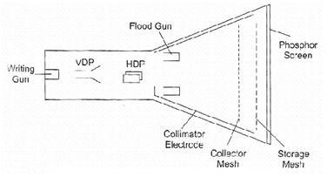

Fig.1.18Analog storage mesh CRT

# Digital Storage Oscilloscope:

Analog Storage cathode ray tube has several limitations:

1. There is a short duration of time, in which it can preserve a stored waveform, so the waveform may lose.
2. Trace of storage tube is not as fine as that of a normal CRT.
3. Writing rate of the storage tube is less than that of a conventional CRT which in turn limits the

speed of the analog storage oscilloscope.

1. It is more expensive than a conventional CRT and requires additional power supplies.
2. Only one image can be stored. For comparing two traces they are to be superimposed on the same and displayed together.

Digital storage oscilloscope is used to limit these limitations. In DSO, the waveform to be stored is digitized, stored in a digital memory and retrieved for display on the storage oscilloscope.

Stored waveform is continuously displayed by repeatedly scanning it. Therefore a conventional

CRT can also be used for the display. The stored display can be displayed continuously as long as the power is applied to the memory which can be supplied from a small battery.

Digitized waveform can be analyzed by oscilloscope or by reading the contents of the memory into the computer. Display of the stored data is possible in both amplitude versus time and x-y modes. In DSO, fast memory readout is used for CRT display in addition to this a slow readout is also possible which is used for development of hard copy externally.

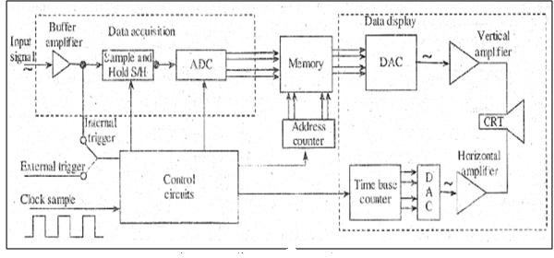

Fig.1.19.The Block diagram of DSO Figure shows the block diagram of DSO as consists of,

1. Data acquisition
2. Storage
3. Data display.

Data acquisition is earned out with the help of both analog to digital and digital to analog converters, which is used for digitizing, storing and displaying analog waveforms. Overall operation is controlled by control circuit which is usually consists of microprocessor.

Data acquisition portion of the system consist of a Sample-and-Hold (S/H) circuit and an analog to digital converter (ADC) which continuously samples and digitizes the input signal at a rate determined by the sample clock and transmit the digitized data to memory for storage. The control circuit determines whether the successive data points are stored in successive memory location or not, which is done by continuously updating the memories.

When the memory is full, the next data point from the ADC is stored in the first memory location writing over the old data. The data acquisition and the storage process is continues till the control circuit receive a trigger signal from either the input waveform or an external trigger source. When the triggering occurs, the system stops and enters into the display mode of operation in which all or some part of the memory data is repetitively displayed on the cathode ray tube.In display operation, two DACs are used which gives horizontal and vertical deflection voltage for the CRT Data from the memory gives the vertical deflection of the electron beam, while the time base counter gives the horizontal deflection in the form of staircase sweep signal. The screen display consist of discrete dots representing the various data points but the number of dot is very large as 1000 or more that they tend to blend together and appear to be a smooth continuous waveform. The display operation ends when the operator presses a front-panel button and commands the digital storage oscilloscope to begin a new data acquisition cycle.

# Uses of Digital Storage Oscilloscope

* Used for testing signal voltage in circuit debugging.
* Testing in manufacturing.
* Designing.
* Testing of signals voltage in radio broadcasting equipment.
* In the field of research.
* Audio and video recording equipment.

# Measurement of Voltage Current and Frequency by Oscilloscope:

Normally, an oscilloscope is an important tool in an [electrical field](http://www.electrical4u.com/what-is-electric-field/) which is used to display the graph of an electrical signal as it varies with respect to time. But some of the scopes has additional features apart from their fundamental use. Many oscilloscopes have the measurement tool that help to measure waveform characteristics like frequency, voltage, amplitude, and many more features with an accuracy. Generally, a scope can measure time- based as well as voltage-based characteristics.

# Voltage Measurement:

The oscilloscope is mainly voltage oriented device or we can say that it is a [voltage](http://www.electrical4u.com/voltage-or-electric-potential-difference/) measuring device. Voltage, [current](http://www.electrical4u.com/electric-current-and-theory-of-electricity/) and [resistance](http://www.electrical4u.com/electrical-resistance-and-laws-of-resistance/) all are internally related to each other. Just measure the voltage, rest of the values is obtained by calculation. Voltage is the amount of electric potential between two points in a circuit.

It is measured from peak-to-peak amplitude which measures the absolute difference between the maximum point of signal and its minimum point of the signal. The scope displays exactly the maximum and minimum voltage of the signal received. After measuring all high and low voltage points, scope calculates the average of the minimum and maximum voltage. But you must be careful to mention which voltage you mean. Normally, oscilloscope has fixed input range, but this can be easily increased with the use of simple potential divider circuit.

# Method to Measure Voltage:

1. The simplest way to measure signal is to set the trigger button to auto that means oscilloscope start to measure the voltage signal by identifying the zero voltage point or peak voltage by itself. As any of these two points identified the oscilloscope triggers and measure the range of the voltage signal.
2. Vertical and horizontal controls are adjusted so that the displayed image of the sine wave is clear and stable. Now take measurements along the center vertical line which has the smallest divisions. Reading of the voltage signal will be given by vertical control.

# Current Measurement:

Electrical current cannot be measured directly by an oscilloscope. However, it could be measured indirectly within scope by attaching probes or resistors. Resistor measures the voltage across the points and then substituting the value of voltage and resistance in Ohm’s law and calculates the value of electrical current. Another easy way to measure current is to use a clamp-on current probe with an oscilloscope.

# Method to Measure Current

1. Attach a probe with the register to an electrical circuit. Make sure that resistor’s power rating should be equal or greater than the power output of the system.
2. Now take the value of resistance and plug into Ohm’s Law to calculate the current. According to [Ohm’s Law](http://www.electrical4u.com/ohms-law-equation-formula-and-limitation-of-ohms-law/),

http://www.electrical4u.com/images/january16/1453788919.GIF

# Frequency Measurement:

Frequency can be measured on an oscilloscope by investigating the frequency spectrum of a signal on the screen and making a small calculation. Frequency is defined as the several times a cycle of an observed wave takes up in a second. The maximum frequency of a scope can measure may vary but it always in the 100’s of MHz range. To check the performance of response of signals in a circuit, scope measures the rise and fall time of the wave.

# Method to Measure Frequency

1. Increase the vertical sensitivity to get the clear picture of the wave on the screen without chopping any of its amplitude off.
2. Now adjust the sweep rate in such a way that screen displays a more than one but less than two complete cycles of the wave.
3. Now count the number of divisions of one complete cycle on the graticule from start to end.
4. Now take horizontal sweep rate and multiply it with the number of units that you counted for a cycle. It will give you the period of the wave. The period is the number of seconds each repeating waveform takes. With the help of period, you can simply calculate the frequency in cycles per second (Hertz).

# Lissajous Patterns of CRO or Cathode Ray Oscilloscope:

When both pairs of the deflection plates (horizontal deflection plates and vertical deflection plates) of CRO (**Cathode Ray Oscilloscope**) are connected to two sinusoidal voltages, the patterns appear at CRO screen are called the **Lissajous pattern**. Shape of these **Lissajous pattern** changes with changes of phase difference between signal and ration of frequencies applied to the deflection plates (traces) of **CRO**. Which makes these **Lissajous patterns** very useful to analysis the signals applied to deflection plated of CRO.

These lissajous patterns have two Applications to analysis the signals. To calculate the phase difference between two sinusoidal signals having same frequency. To determine the ratio frequencies of sinusoidal signals applied to the vertical and horizontal deflecting plates.

***Calculation of the phase difference between two Sinusoidal Signals having same frequency*** When two sinusoidal signals of same frequency and magnitude are applied two both pairs of deflecting plates of **CRO**, the Lissajous pattern changes with change of phase difference between signals applied to the CRO.

The different value of phase differences, the shape of Lissajous patterns is shown in figure below,

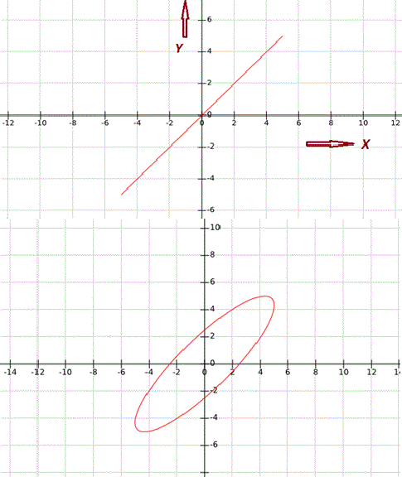

|  |  |  |
| --- | --- | --- |
| **S.NO** | **Phase angle difference ‘ø’** | **Lissajous Pattern appeared at CRO Screen** |
| **1** | 0° & 360° |  |
| **2** | **30° or**  **330°** |  |
| **3** | **45° or**  **315°** | http://www.electrical4u.com/addpost/images/cro-pattern-2.GIF |

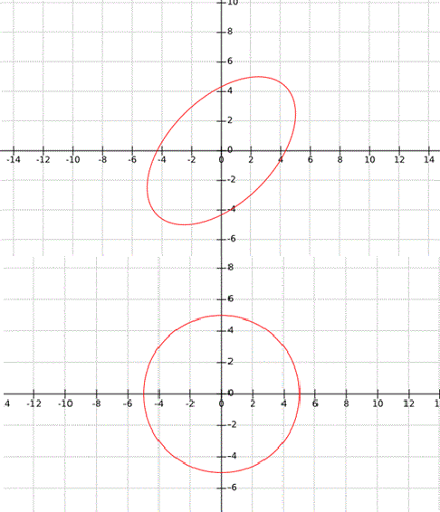

|  |  |  |
| --- | --- | --- |
| **4** | **60° or**  **300°** |  |
| **5** | **90° or**  **270°** |  |

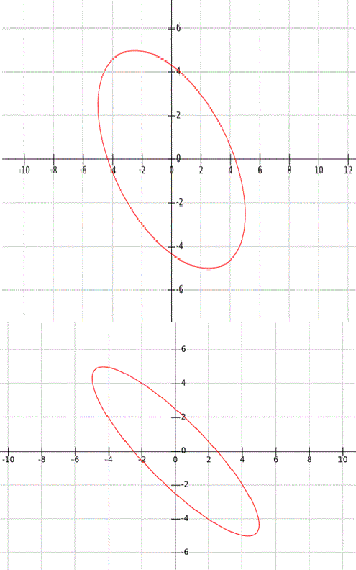

|  |  |  |
| --- | --- | --- |
| **6** | **120° or**  **240°** |  |
| **7** | **150° or**  **210°** |  |
| **8** | **180°** | http://www.electrical4u.com/addpost/images/cro-pattern-8.GIF |

Fig 1.20. Measurment of phase

There are two cases to determine the phase difference ø between two signals applied to the horizontal & vertical plates,

### Case - I:

When, 0 < ø < 90° or 270° < ø < 360° : - As we studied above it clear that when the angle is in the range of 0 < ø < 90° or 270° < ø < 360°, the Lissajous pattern is of the shape of Ellipse having major axis passing through origin from first quadrant to third quadrant: Let’s consider an example for 0 < ø < 90° or 270° < ø < 360°, as shown in figure below,

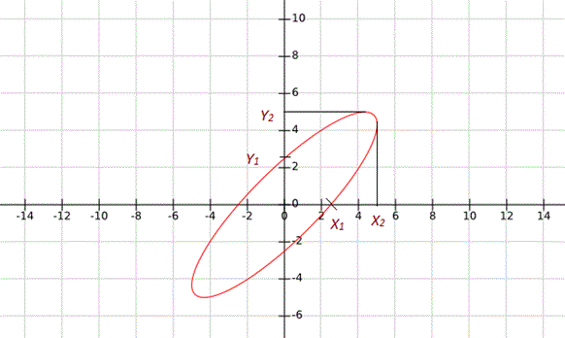

Fig 1.21 Lissajous pattern in 1& 3 quadrants In this condition the phase difference will be,

http://www.electrical4u.com/addpost/images/10-10-15-1.GIFAnother possibility of phase difference, http://www.electrical4u.com/addpost/images/10-10-15-2.GIF From Above given Lissajous pattern

http://www.electrical4u.com/addpost/images/10-10-15-4.GIFhttp://www.electrical4u.com/addpost/images/10-10-15-5.GIFhttp://www.electrical4u.com/addpost/images/10-10-15-3.GIF Another Possibility of Phase Difference,

**case - II:**When 90° < ø < 180° or 180° < ø < 270°

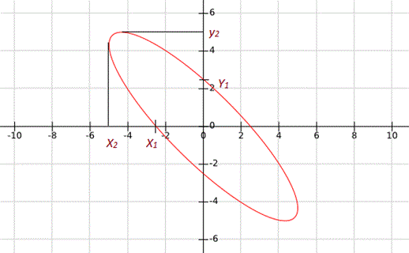

Fig 1.22 Lissajous pattern in 2& 4 quadrants

As we studied above it Clear that when the angle is in the range of 0° < ø < 90° or 270° < ø < 360°, the Lissajous Pattern is of the shape of Ellipse having major axis passing through origin from second quadrant to fourth quadrant:

Let’s consider an example for When, 90° < ø < 180° or 180° < ø < 270°, as shown in figure below, In this condition the phase difference will be,

http://www.electrical4u.com/addpost/images/10-10-15-6.GIF

Another possibility of phase difference,

http://www.electrical4u.com/addpost/images/10-10-15-7.GIF

From Above given Lissajous pattern

http://www.electrical4u.com/addpost/images/10-10-15-8.GIF

http://www.electrical4u.com/addpost/images/10-9-15-13.GIF

Another Possibility of Phase Difference,

http://www.electrical4u.com/addpost/images/10-9-15-14.GIF

To determine the ratio of frequencies of signal applied to the vertical and horizontal deflecting plates: To determine the ratio of frequencies of signal by using the Lissajous pattern, simply draw arbitrary horizontal and vertical line on lissajous pattern intersecting the Lissajous pattern. Now count the number of horizontal and vertical tangencies by Lissajous pattern with these horizontal and vertical line. Then the ratio of frequencies of signals applied to deflection plates,

http://www.electrical4u.com/addpost/images/10-9-15-15.GIFhttp://www.electrical4u.com/addpost/images/10-9-15-16.GIF